**Dave Moran Capstone 2 Project**

The site itself is still running here: http://3.215.180.67/index.html

**Project Work Flow:**

I worked on this project a couple of times and had a lot of problems with permissions allowing me to create EC-2’s, or other times I could create the EC-2 and could not create the security group.

Sometimes I could do neither.

Because of this issue I decided to use my personal AWS account and build the server there.

1. Server: I built a nano-server with a new VPC, security group and public subnet.
2. I used the ppk file to connect to the instance using putty and installed the AWS CLI, git and docker.
3. I then installed cloud9 as it’s my server and cloud9 is way more pleasant to use than Putty.
4. It took forever to figure out how to connect my git account to the server, but after many tutorials I finally got it connected and then pulled the site image out of my github.
5. I made changes to the site.
6. I committed the changes to a new branch.
7. I created the Dockerfile. Committed the changes.
8. I created the IAC directory and the yaml file within.
9. I created a directory named containers and one beneath it called capstone2.
10. I copied all of the site files there.
11. I ran the command docker build –tag davemoran-capstone2 . to build the image
12. I ran the command docker images to make sure my image was available.
13. I ran the command docker run -d -p 80:80 davemoran-capstone2 to run the container.
14. I ran the command curl <http:///localhost:80> to make sure that the site was running.
15. I went back into AWS and edited the security group to all inbound access to port 80 and then went to <http://3.215.180.67/index.html> to view the site in the browser.
16. I poked around and viewed my changes and was very proud of myself.
17. I was then very sad to learn that I had no idea how to create a CloudFront template and looked for documentation and even watched an AWS video here:

<https://aws.amazon.com/cloudfront/getting-started/EC2/>

1. I created a load balancer, a second subnet in another AZ and a target group.
2. Finally I created a CloudFront distribution and this is the URL: <https://d2bpljxj5h22py.cloudfront.net>
3. This didn’t work, so instead I created a launch template from the running server which will installs cloud9, git and docker automatically.

**Documentation and screenshots:**

1. Github link: <https://github.com/daivmoran/daves-capstone.git>
2. Screenshot from Github:

1. Docker container name: stoic_gould

Image: davemorancapstone2:latest

1. Docker repo URL: <https://hub.docker.com/repository/docker/davetheitguy/davemoran-capstone2/general>
2. Docker repo screenshot:

1. Screenshot of home page

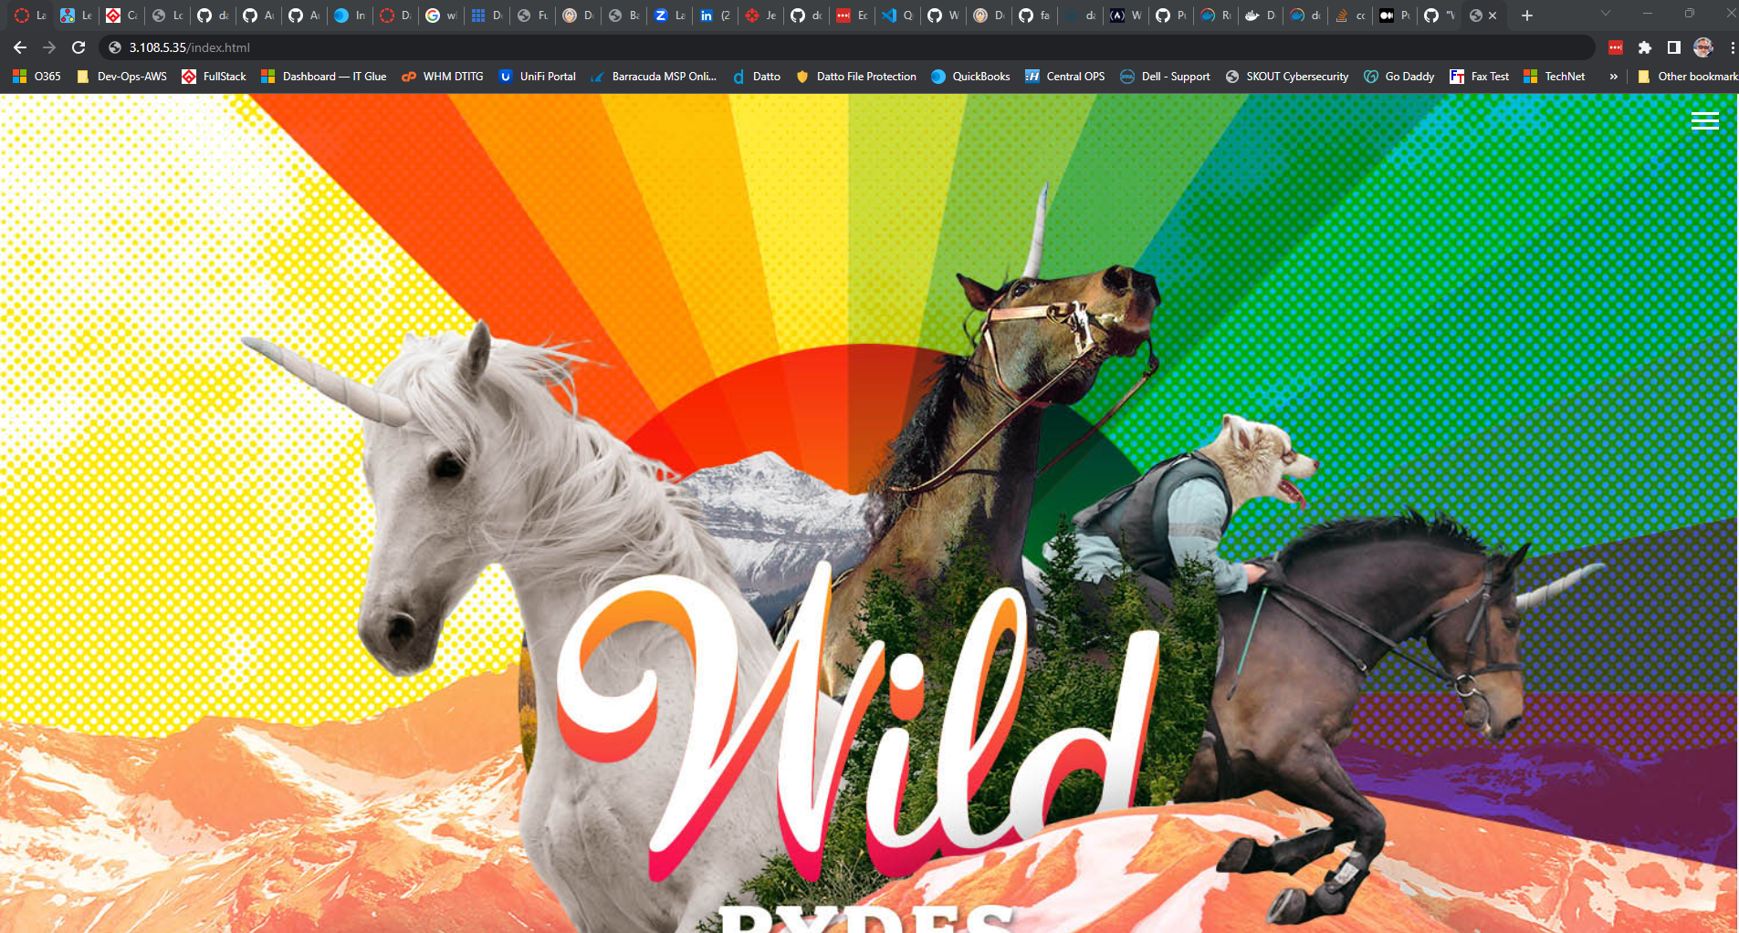

7) Screenshot of homepage with edits:

8) Screenshot with FAQ additions

9) Output of curl command:

10) CloudFront Distribution:

<https://d2bpljxj5h22py.cloudfront.n>

10) Created a launch template:

